The Value of the IB Diploma Programme

Comparison of four- to six-year graduation rates from US universities 2008-2014.
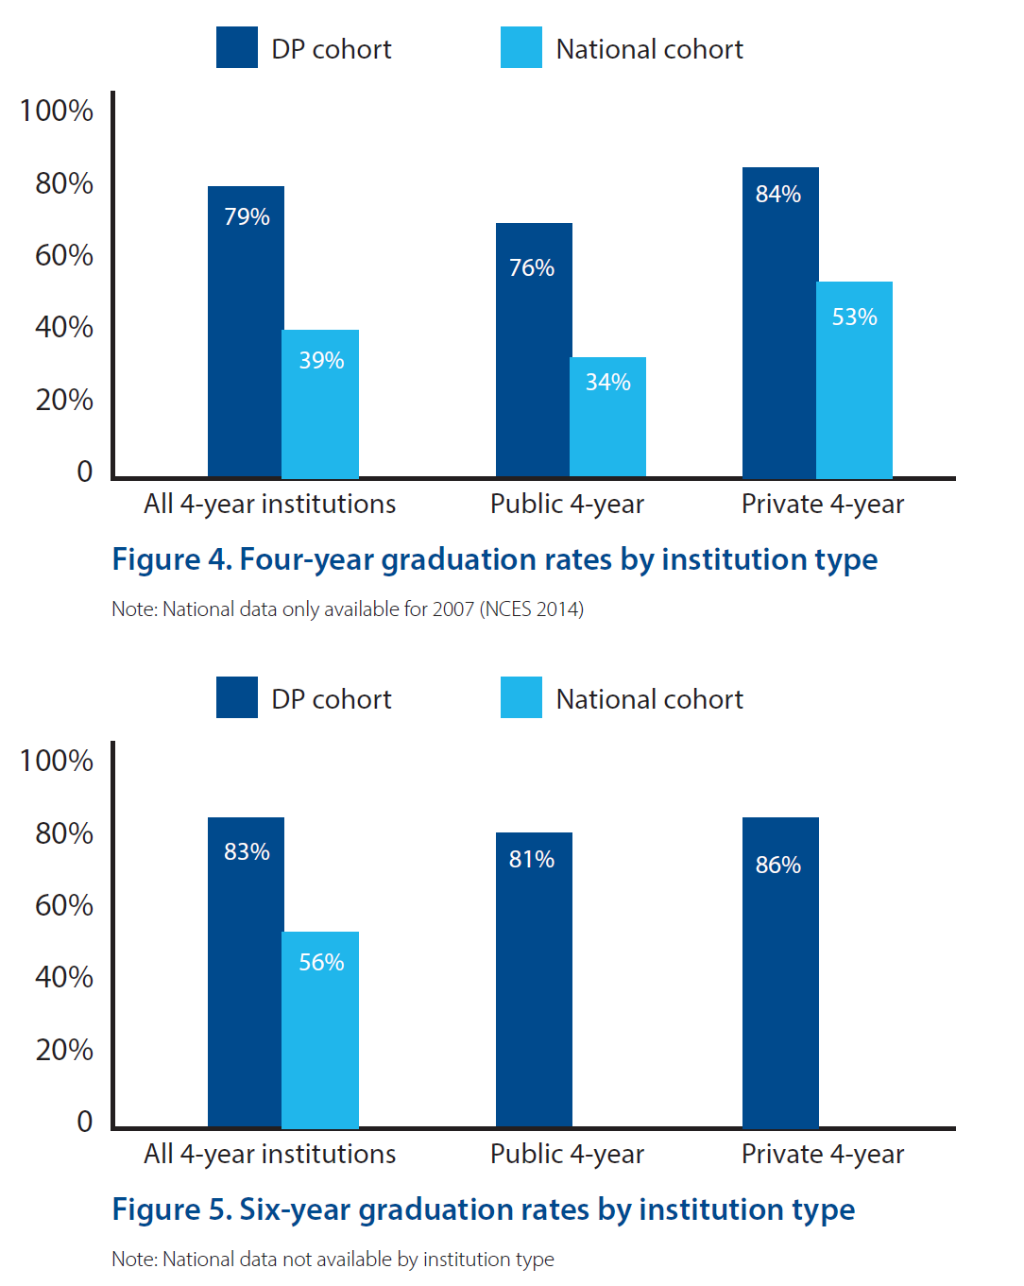
Australian and New Zealand admissions officers’ perceptions of university preparation
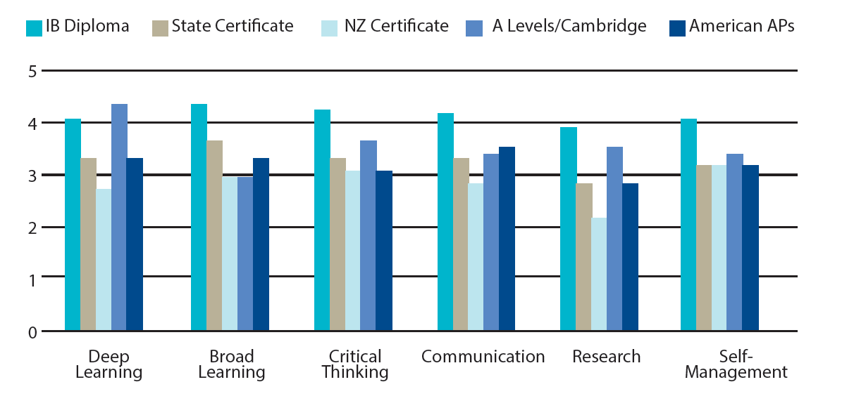

In a survey of all new students at the University of British Columbia at the start of their first semester, DP students were at least 20% more likely to rate their following skills as “very good” or “excellent”: research, ability to read and comprehend academic material, ability to make and prepare a presentation and ability to write clearly and effectively. At the end of their first semester, DP students were also considerably more likely to have participated in student leadership activities, volunteer work, tutoring/ teaching other students and student clubs/ organizations.

Students claim “...richer curriculum with a wider range of topics they could discuss in some depth. They also felt that, as a result of being in IB, they developed good critical thinking skills.

DP students from Title I schools enroll in college at the same rate as DP students from US public schools generally (82%). Low-income DP students from Title I schools at very high rates (79%). This rate is comparable to overall DP student postsecondary enrollment and substantially higher than the national average for low-income students (46%).
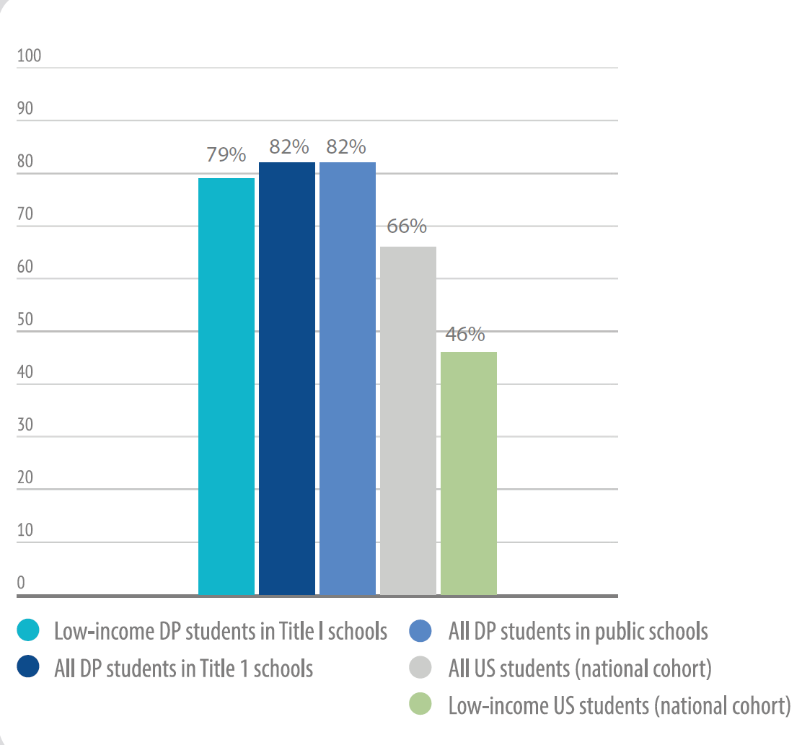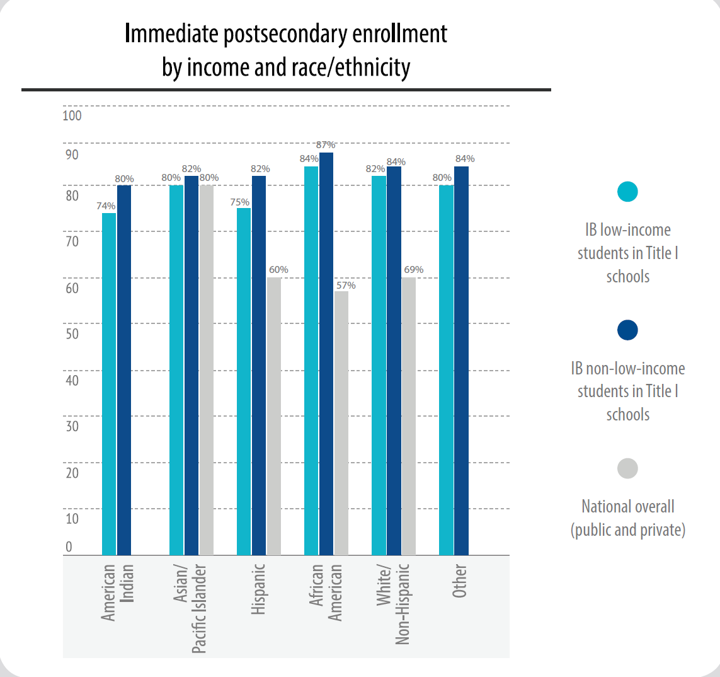

“...the rigor⍏ of courses an applicant completed while in high school is the most important indicator in determining an applicant’s academic merit...a more demanding route demonstrate[s] their eagerness to learn, accept academic challenges, and push themselves...This finding is presented in contrast to the commonly held assumption that standardized test scores and/or grades are the most important factors in determining an applicant’s merit.”

Acceptance rates for IB candidates are higher (an average of 22%, between 3% and 13% for ivy league universities) than of the total population.
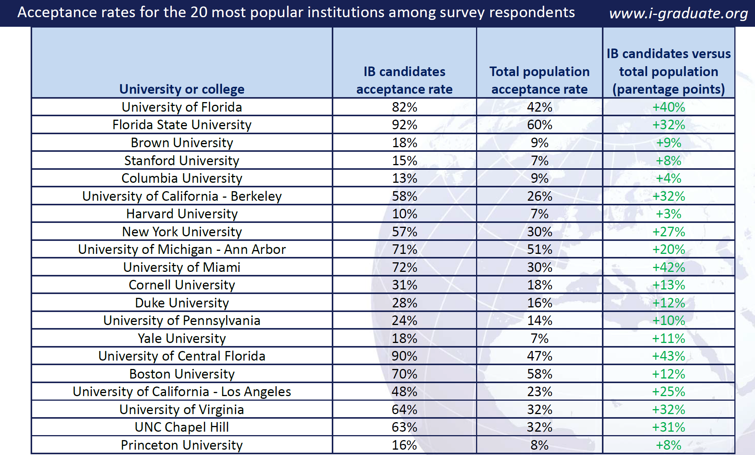

Bergeron, L. 2015. Diploma Programme students’ enrollment and outcomes at US postsecondary institutions 2008–2014. Bethesda, MD, USA. International Baccalaureate Organization.
Coates H, Rosicka C and MacMahon-Ball, M. 2007. Perceptions of the International Baccalaureate Diploma Programme among Australian and New Zealand Universities. Camberwell, VIC, Australia. Australian Council for Educational Research. http://www.ibo.org/programmes/research/resources/acerperception/perceptions.
Bluhm,M. July 2011. First year university experience of IB graduates. San Antonio, Texas, US. IB Conference of the Americas.
Taylor, M and Porath, M. 2006. Reflections on the International Baccalaureate Program: graduates’ perspectives. The Journal of Secondary Gifted Education. Vol 27, issue 3. Pp 21-30.
2011. The IB diploma graduate destinations survey 2011 - US. International Graduate Insight Group. http://www.ibo.org/contentassets/12ca22e438df4a65b4c92e42b70b10ea/globaldpdestinationsurveyus.pdf ⍏In this paper, “rigor” refers to the extent to which an applicant completed the most difficult courses available at his or her secondary institution.
Rubin, Rachel. 2014. Who gets in and why? An examination of admissions to America’s most selective colleges and universities. International Education Research. Vol 2, issue 2. Pp1-18.
Gordon, Melissa, Emily VanderKamp and Olivia Halic, 2015 “Research Brief: International Baccalaureate programmes in Title I schools in the United States: Accessibility, participation, and university enrollment.” IB Global Research.

